“ADJ” Hospital Management System

System Requirements Specification

A.T.Udyani

SCS 2104

15001377

**Content**

**1. Introduction 1-1**

1.1 Purpose of the System 1

1.2 Scope of the product 1

**2. General Description 2-2**

2.1 Product perspective 2

2.2 General Constrains 2

**3. Requirements 3-3**

3.1 Functional Requirements 3

3.2 None Functional Requirements 3

**4.Appendices 4-4**

4.1 ER Diagram 4

4.2 Table Mapping 4

4.3 Class Diagram 4

4.4 User Interface 4

**1. Introduction**

1.1 Purpose of the System

The main purpose of our system is to make hospital task easy and is to develop software that replaces the manual hospital system into automated hospital management system. This document serves as the unambiguous guide for the developers of this software system.

1.2 Scope of the product

The document only covers the requirement specification for the hospital management system. This document does not provide any references to the other component of the hospital management system. All the external interfaces and the dependencies are also identified in this document.

Both patients’ personal details and admit details are managing through the system. And also Staff details and Salary calculation, Test and Treatment details are managing by this Hospital Management System.

**2. General Description**

The system is desired to handle all the activities of the hospital as well as the administrative level. The system will have the ability to search the student’s information about his/her room mess and all the other things. Once the current and previous record is entered then the database will be updated for the new students automatically. This system is for hostel so that the primary users of the system is administrative panel.

2.1 Product perspective

Hospital management by manual way is tedious process, since it involves work load and time consumption. In this system, we can easily manage the patient details, staff details, ward details, staff attendance records, billing details calculation, easy way of room allocation and hostel attendance.

The HMS is an independent stand–alone system. It is totally self-contained.

2.2 General Constrains

The system is desired to handle all the activities of the staff as well as the treatments and tests of patients. The system will have the ability to search the patients’ personal information treatments, test by their patient Id. Once the current and previous record is entered then the database will be updated for the new patient automatically.

o System will use receptionist of the hospital.

o The Hospital id card is necessary to use mess.

o Time constraint

o GUI is only in English.

o Login and password is used for identification of user and there is no facility for guest.

**3. Requirements**

3.1 Functional Requirements

* Maintain Patient Details
  + Add patient details

The System shall allow user to add new patient to the system (Register patients.)

* + Update patient details

The System shall allow user to edit and update details of already registered patients’. (Update patients details.)

* + Add patient details

The System shall allow user to delete registered patients’ details. (Delete patients details.)

* Maintain Staff Details
  + Add staff details

The System shall allow user to add new staff to the system (Register staff.)

* + Update staff details

The System shall allow user to edit and update details of already registered staff. (Update staff details.)

* + Add patient details

The System shall allow user to delete registered staff details. (Delete staff details.)

* Maintain Test Details
  + Add test details

The System shall allow user to add new test detail to the system (Add test.)

* + Update test details

The System shall allow user to edit and update already entered test details. (Update test details.)

* + Add test details

The System shall allow user to delete already entered test details. (Delete test details.)

* Maintain Treatment Details
  + Add treatment details

The System shall allow user to add new treatment detail to the system (Add treatment.)

* + Update treatment details

The System shall allow user to edit and update already entered treatment details.

* + Add patient details

The System shall allow user to delete registered staff details. (Delete staff details.)

* Maintain Salary
  + Update attendance

The System shall allow user to update staff attendance and calculate salary.

**4.Appendices**

4.1 ER Diagram

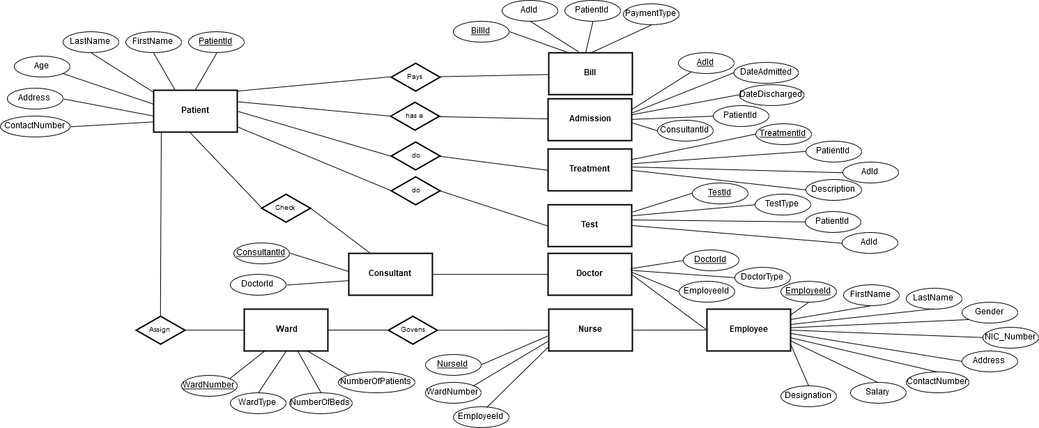

4.2 Table Mapping

.

4.3 Class Diagram

.

4.4 User Interface

* Login

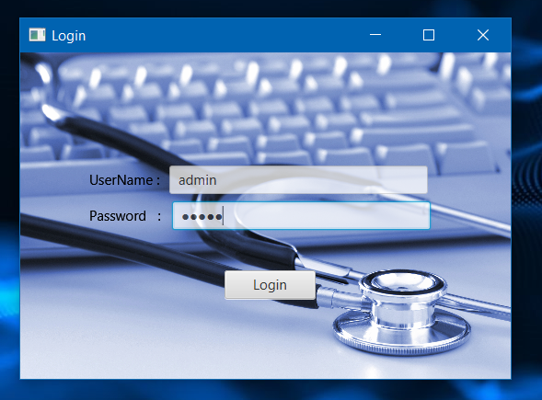

* Home page

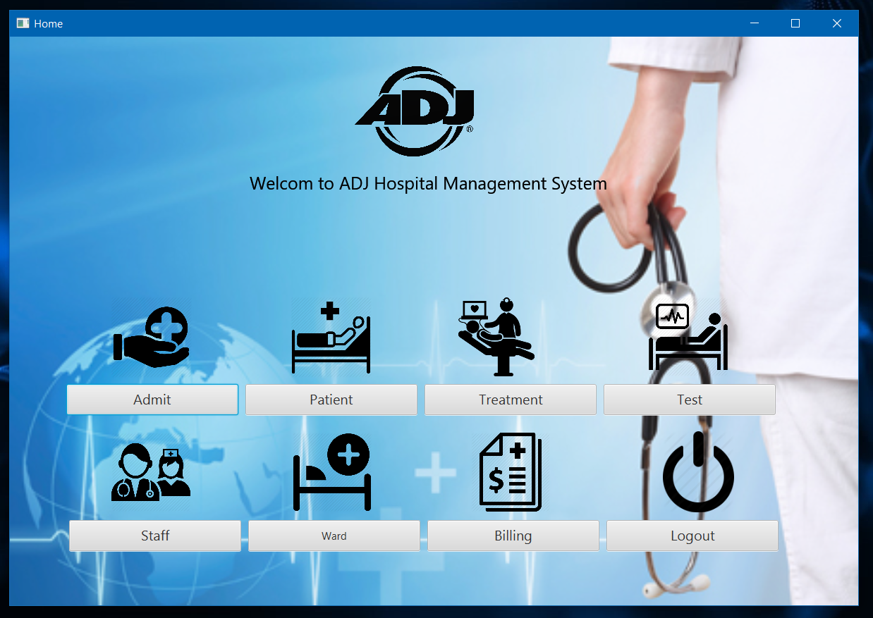

* Patient

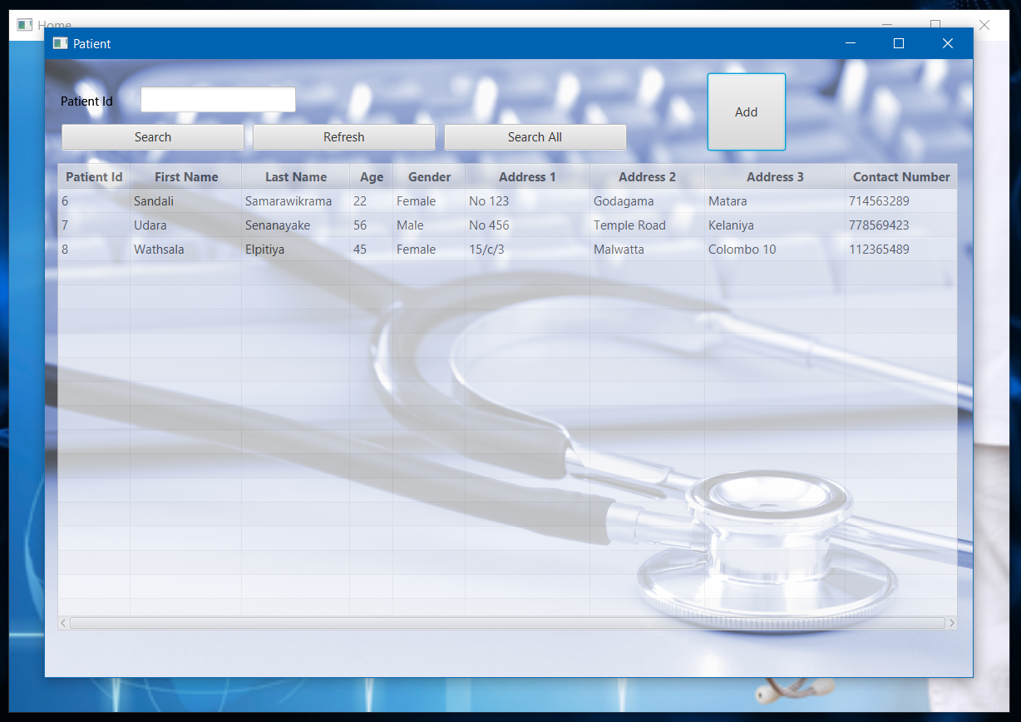

* Add Patient details

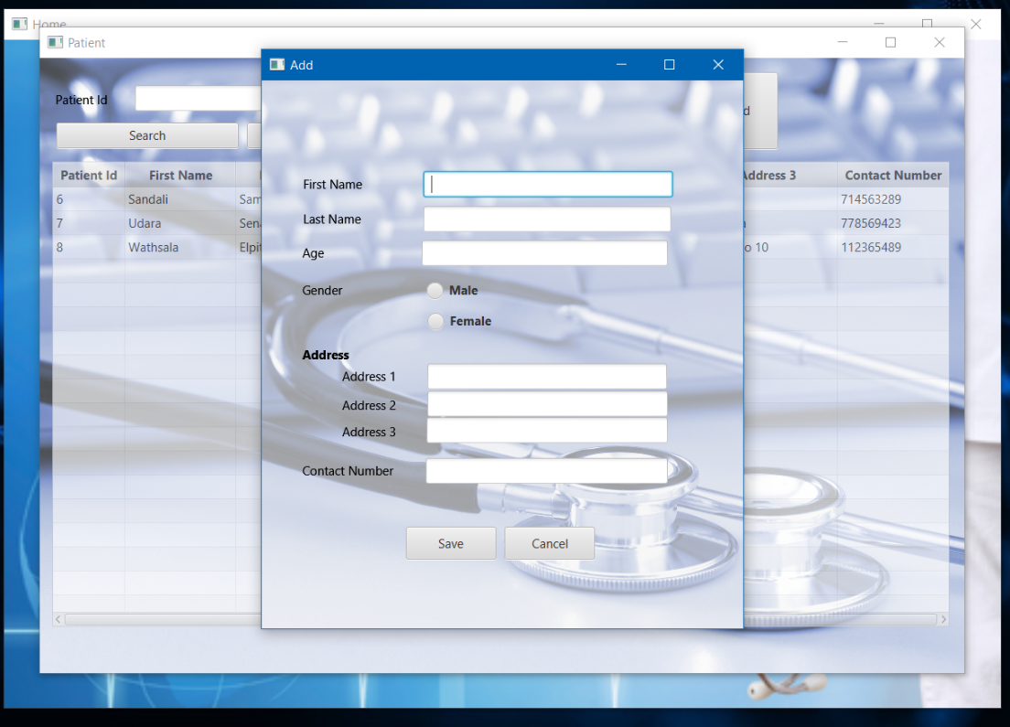

* Update / Delete Patient details

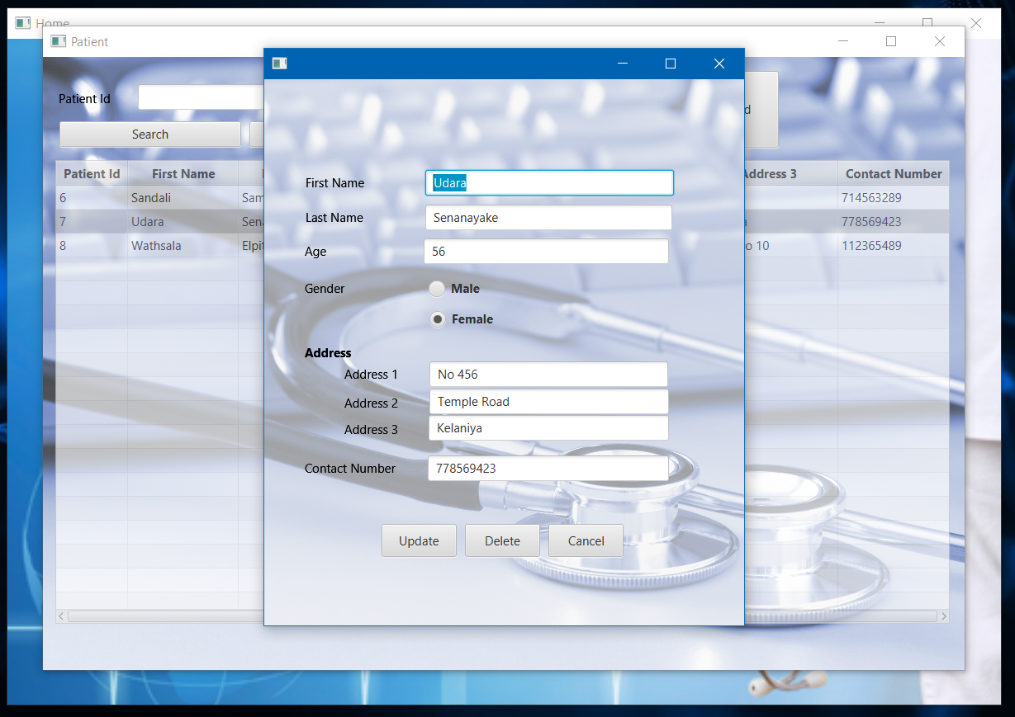

* Staff
* Add Staff details
* Update / Delete Staff details
* Treatment
* Add Treatment details
* Update / Delete Treatment details
* Test
* Add Test details
* Billing
* Other
* Other